LAB # 08
Open Ended Lab

Open-Ended Lab Task: GitHub Integration and Concurrency in Java
Objective: In this lab, you will explore essential practices for using GitHub repository and understand multithreading and inter-thread communication in Java.

Task Instructions:
- GitHub Repository Setup and Eclipse Integration
  - Create a new GitHub repository for this lab project.
  - Upload files from any eclipse workplace folder and commit changes to your GitHub repository.
  - Deliverable: Document the steps for creating the repository, setting up the Eclipse configuration.
- Concurrency with Multithreading Mechanisms
  - Create a class with multiple threads that perform different tasks (e.g., one thread handles calculations, another handles data logging).
  - Implement the start, sleep, and stop functionalities to demonstrate different thread lifecycle states.
  - Use join() where necessary to ensure one thread completes before another begins, simulating dependency between threads.
  - Deliverable: Code implementing multithreading with clear comments explaining the use of each concurrency method (start, sleep, stop, and join).

- Inter-Thread Communication Using Synchronization
  - Develop a program where two threads communicate via shared resources.
  - Use synchronization techniques (such as synchronized methods or blocks) to ensure that shared resources are accessed safely by each thread.
  - Example scenario: Implement a "Producer-Consumer" pattern, where one thread (Producer) adds items to a buffer, and another thread (Consumer) removes them, using wait() and notify() methods.
  - Deliverable: A fully functional inter-thread communication program demonstrating correct use of synchronization.

Additional Challenge:
- Experiment with ReentrantLock to replace synchronized blocks, allowing for finer control over thread locking.
- Add logging to record thread actions (such as start, wait, notify, stop) to a file for a clear view of thread operations over time.

Evaluation Criteria:
- GitHub repository Mastery: Correctly configure GitHub to upload file on GitHub repository.
- Concurrency Implementation: Effective use of start, sleep, stop, join, synchronization, and thread-safe communication.
- Documentation: Clear and concise explanations of each part of the lab, including screenshots or logs as needed.
Task 1
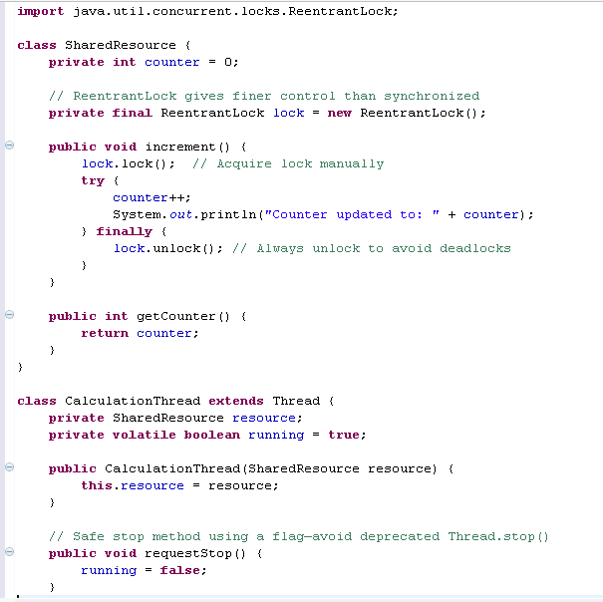
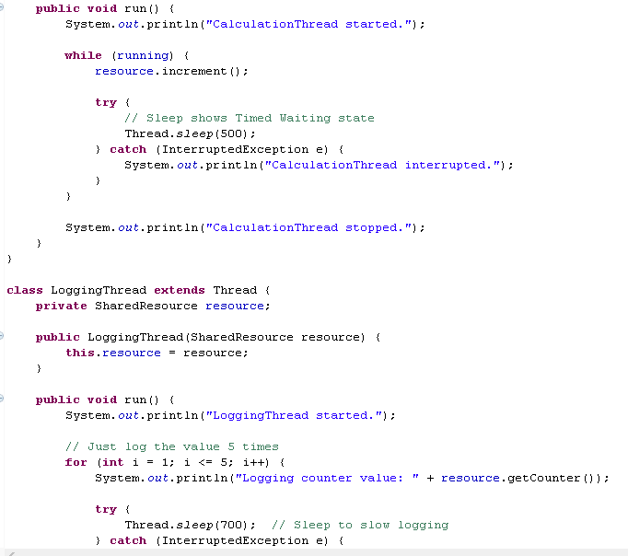
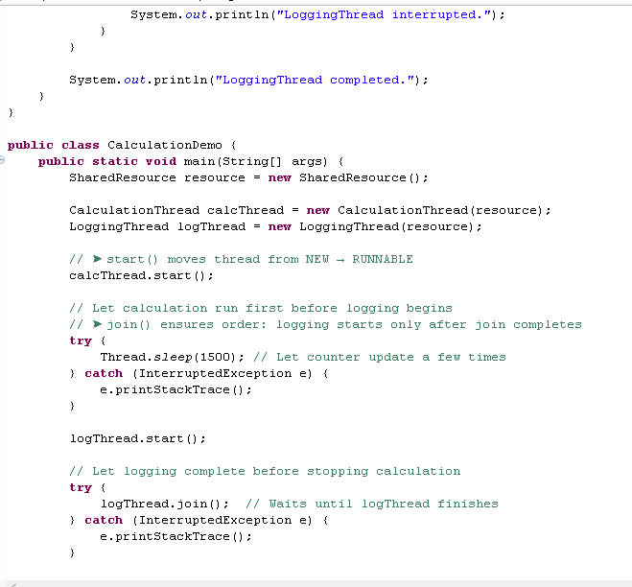
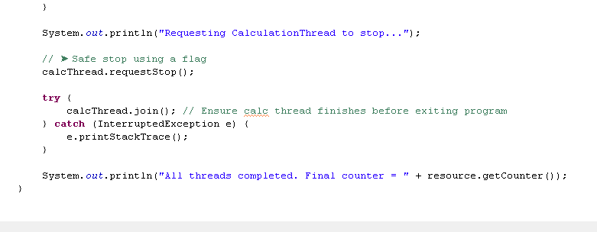
OUTPUT:
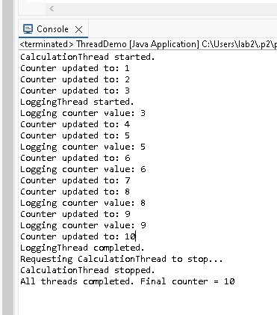
TASK 2:
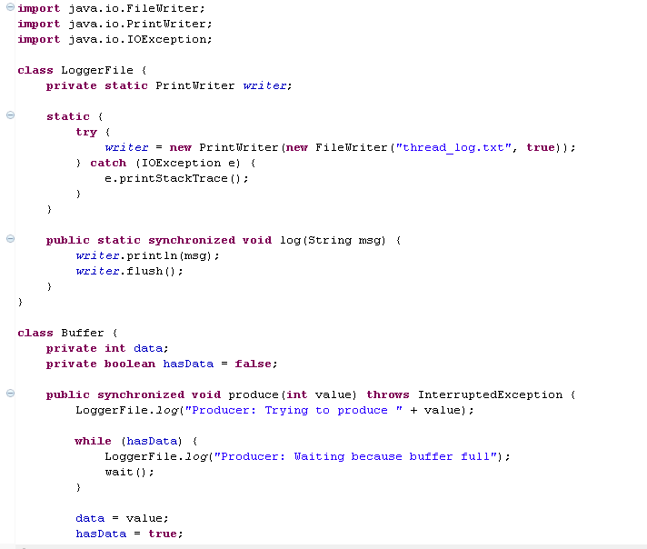
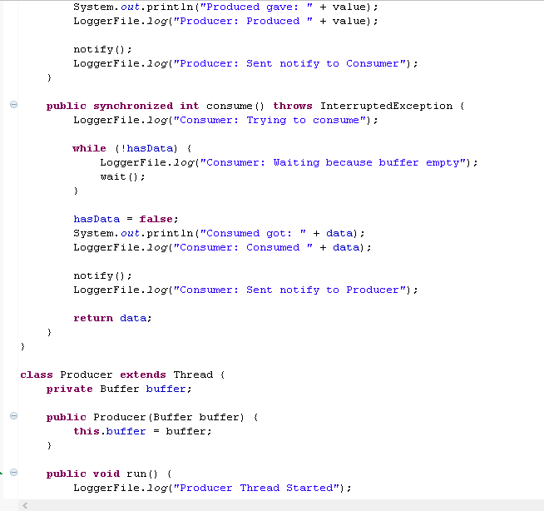
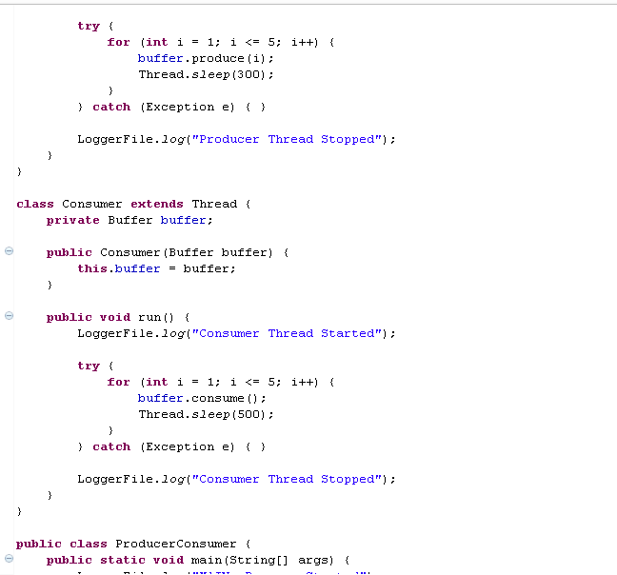
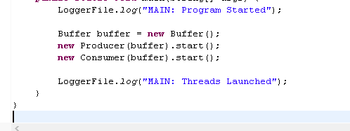

OUTPUT:
